Bonus: - Visualization critique of Assignment 1

Original Visualization:-

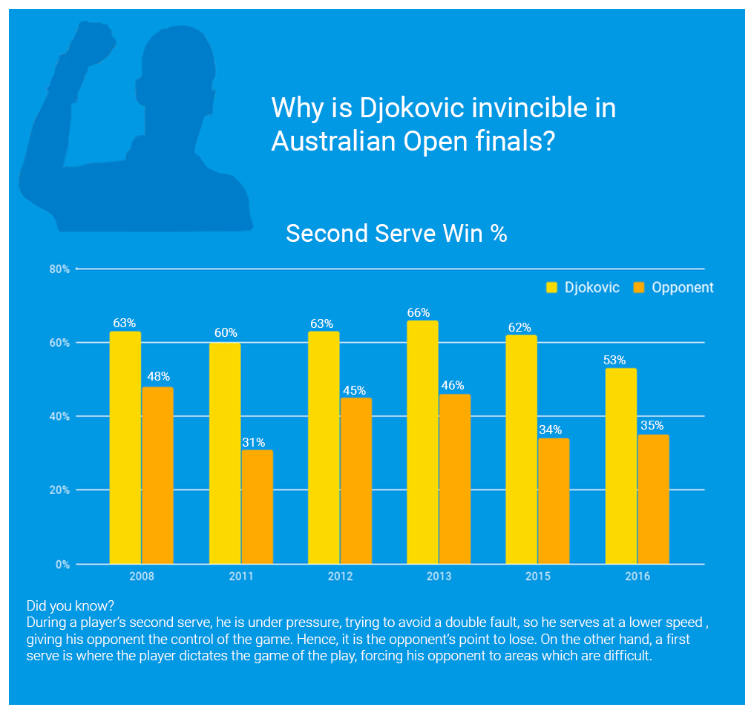

The above visualization shows the reason why Djokovic performs so well in Australian Open Finals. After learning a lot of the visualization techniques, I have realized some of the positives and negatives of this infographic.

Strengths:

* Clean and descriptive design
* The blue color used in the background is similar to the blue color on the Melbourne court, so it strikes some similarity

Weaknesses:

* Contrasting colors haven’t been used for the bar graphs
* Axis Labels not present
* Why the second serve is important is mentioned as a ‘Did you know?’. The title should be more descriptive

